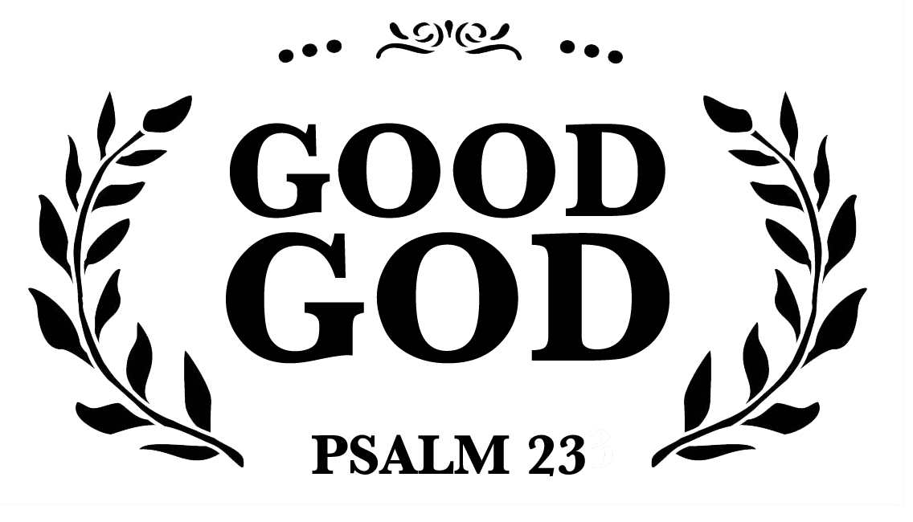
Good God

In Care of the Good Shepherd

June 5, 202

“The Lord is my shepherd; there is nothing I lack. In green pastures he makes me lie down; to still waters he leads me; he restores my soul. He guides me along right paths for the sake of his name. Even though I walk through the valley of the shadow of death, I will fear no evil, for you are with me; your rod and your staff comfort me.” Psalm 23:1-4 (NAB)

A rod is used for ____________________& __________________.

A staff is used for ___________________ & __________________.

The rod & staff represent ______________ & __________________.

How the Good Shepherd Cares

- If I bring Him my hurts, Jesus ________________________________.
Matthew 9:36, Matthew 20:28

- If I choose to follow, Jesus ___________________________________.
John 10:3-4,

- If I wander off, Jesus ________________________________________.
Matthew 18:12, Luke 19:10, Isaiah 53:6

- If I fail or fall, Jesus __________________________________________.
Matthew 12:11-12, John 12:47, Psalm 71:20
- If I trust Him, Jesus __________________________________________.
John 10:27-29

NOTES:

Good God

In Care of the Good Shepherd

June 5, 202

“The Lord is my shepherd; there is nothing I lack. In green pastures he makes me lie down; to still waters he leads me; he restores my soul. He guides me along right paths for the sake of his name. Even though I walk through the valley of the shadow of death, I will fear no evil, for you are with me; your rod and your staff comfort me.” Psalm 23:1-4 (NAB)

A rod is used for ____________________& __________________.

A staff is used for ___________________ & __________________.

The rod & staff represent ______________ & __________________.

How the Good Shepherd Cares

- If I bring Him my hurts, Jesus ________________________________.
Matthew 9:36, Matthew 20:28

- If I choose to follow, Jesus ___________________________________.
John 10:3-4,

- If I wander off, Jesus ________________________________________.
Matthew 18:12, Luke 19:10, Isaiah 53:6

- If I fail or fall, Jesus __________________________________________.
Matthew 12:11-12, John 12:47, Psalm 71:20
- If I trust Him, Jesus __________________________________________.
John 10:27-29

NOTES:

